

root@cyberster:~$ whoami
> hanzallah — soc_intern
Day
74-80
Email & Host-Based Forensics
// candidate Hanzallah
// program Cyberster — Cybersecurity Internship (Batch 2)
// tutor Abdullah Zia
[ STATUS: TASKS COMPLETE — READY FOR REVIEW ]

// 74-80 OVERVIEW & SCOPE

This phase investigates Jean's claim that she emailed the target file, m57plan.xls, to the company President. The investigation proceeds in three parts: email header analysis to establish the actual delivery address, host-based artefact analysis (LNK, prefetch, registry) to corroborate local activity around the file's last-modified timestamp of 2008-07-20 01:28:03 GMT, and a filtered super timeline to confirm the second-level sequence of events. The forensic image used is the split EnCase image nps-2008-jean.E01 / .E02, processed with case timezone set to GMT to match Threat Intel baselining.

// 74-75 PART A — EMAIL EXTRACTION & TRIAGE

$ Phase 1 — Case Setup & Image Ingestion
Case created in Autopsy with the .E01 image added as a data source (E02 auto-stitched). Case timezone set to GMT/UTC.
File → New Case
Case Name: nps-2008-jean
Add Data Source → Disk Image or VM File
Path: nps-2008-jean.E01
Time zone: GMT (Etc/UTC)
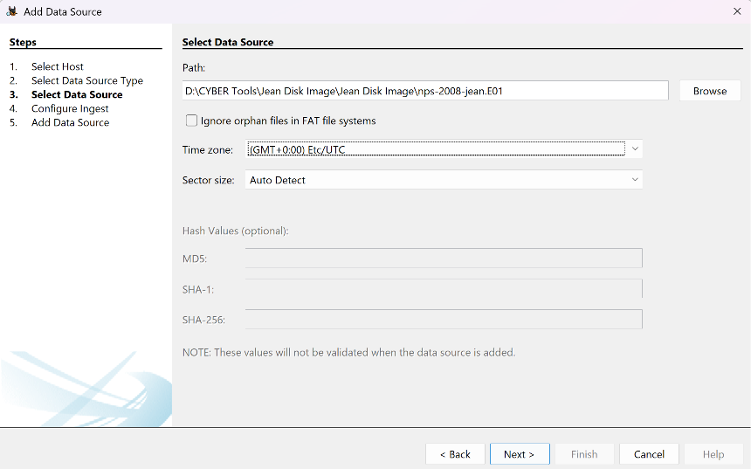

$ Phase 2 — Email Archive Discovery
Image searched for PST, OST, MBOX, and EML files to identify Jean's mail client and storage configuration.
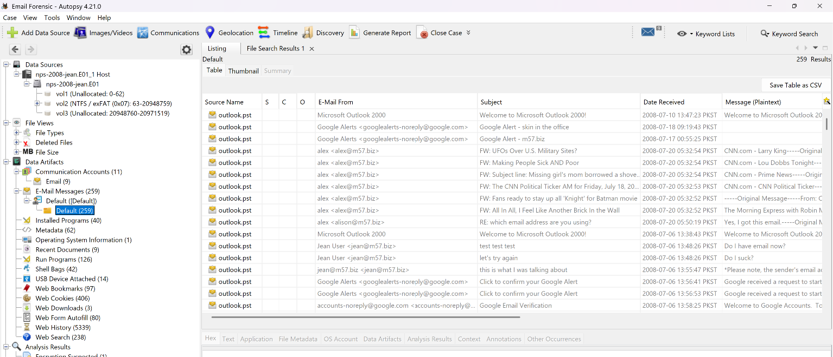
$ Phase 3 — Archive Parsing
Archive parsed via Autopsy's Email Parser ingest module. Where parsing was incomplete, the archive was exported and reparsed with a dedicated tool.
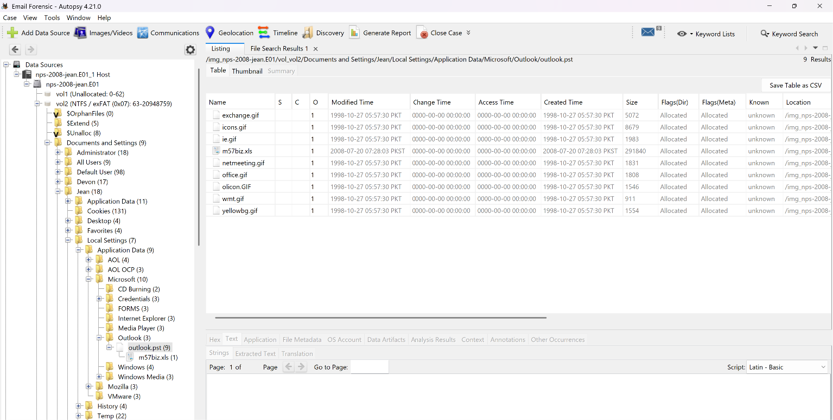

$ Phase 4 — Isolating the m57plan.xls Email (2008-07-20)
Messages sorted/filtered to July 20, 2008; the outbound message carrying the m57plan.xls attachment located near the 01:28:03 GMT anchor.
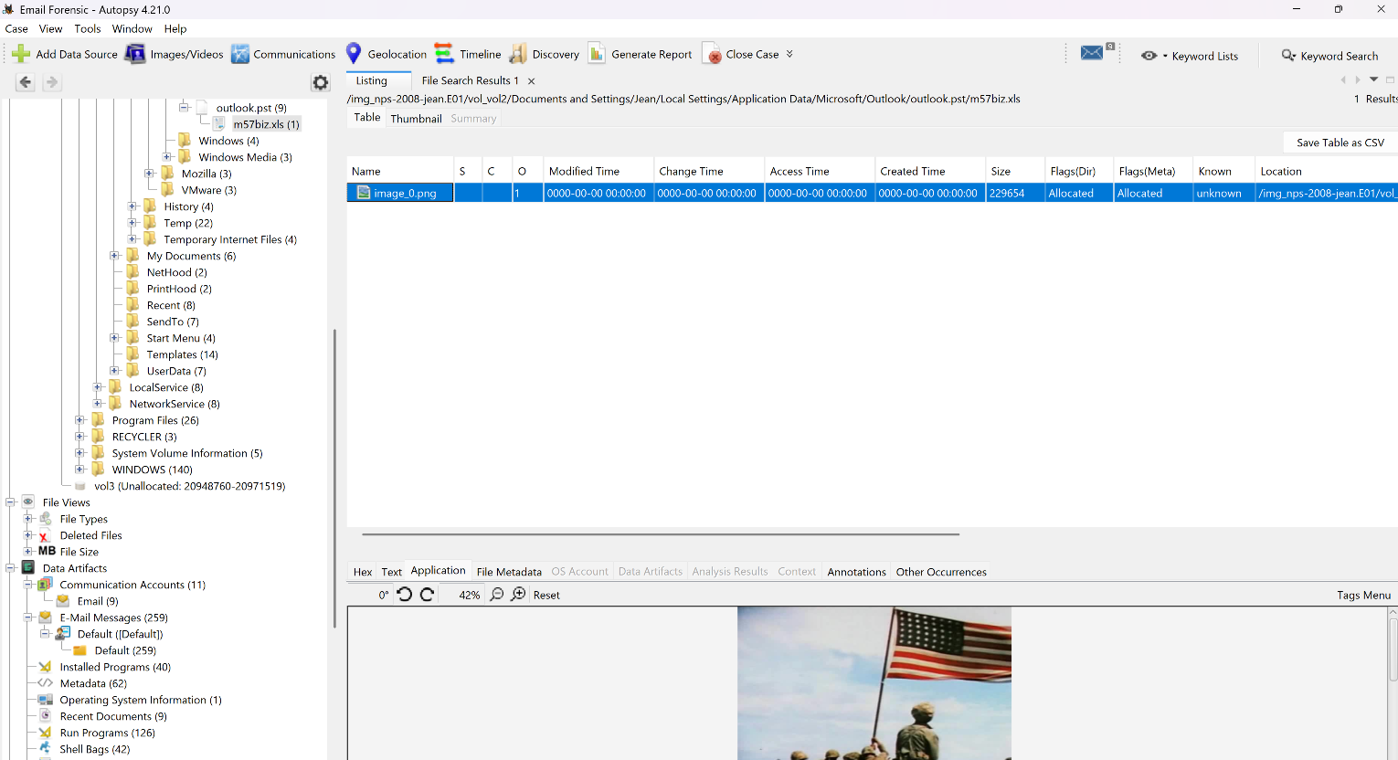
$ Phase 5 — Raw Header Analysis: Display Name vs. Actual Recipient
Raw RFC 2822 headers examined directly — not the client's parsed view — to identify the true delivery address via Delivered-To / X-Original-To / the final Received: hop.
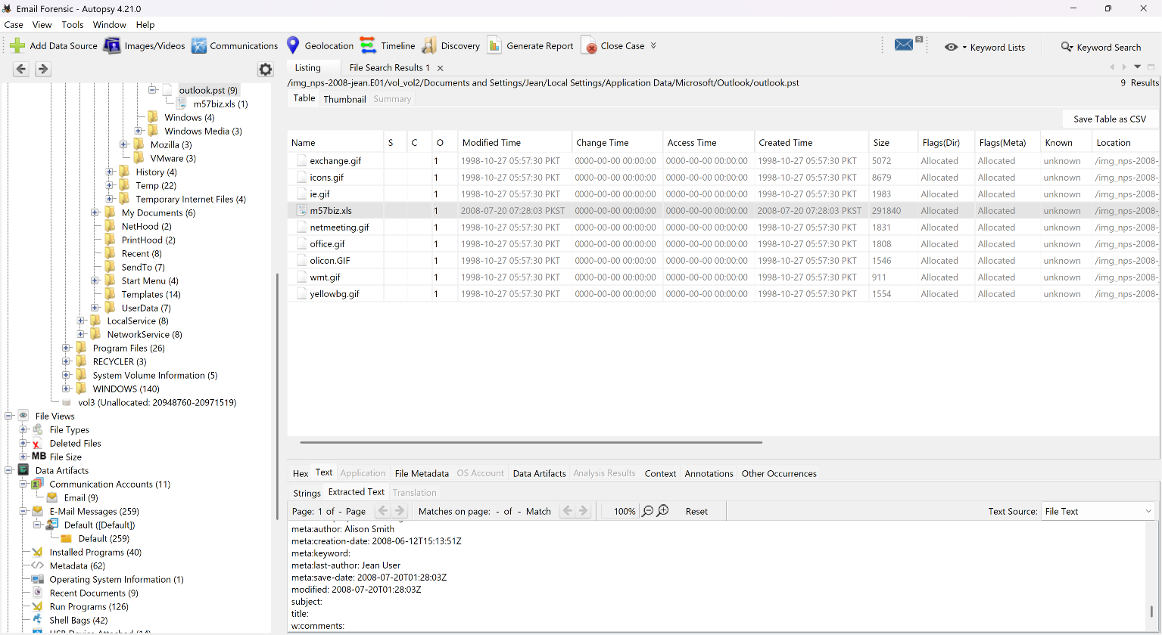

$ Phase 6 — Other Relevant Communications, July 20, 2008
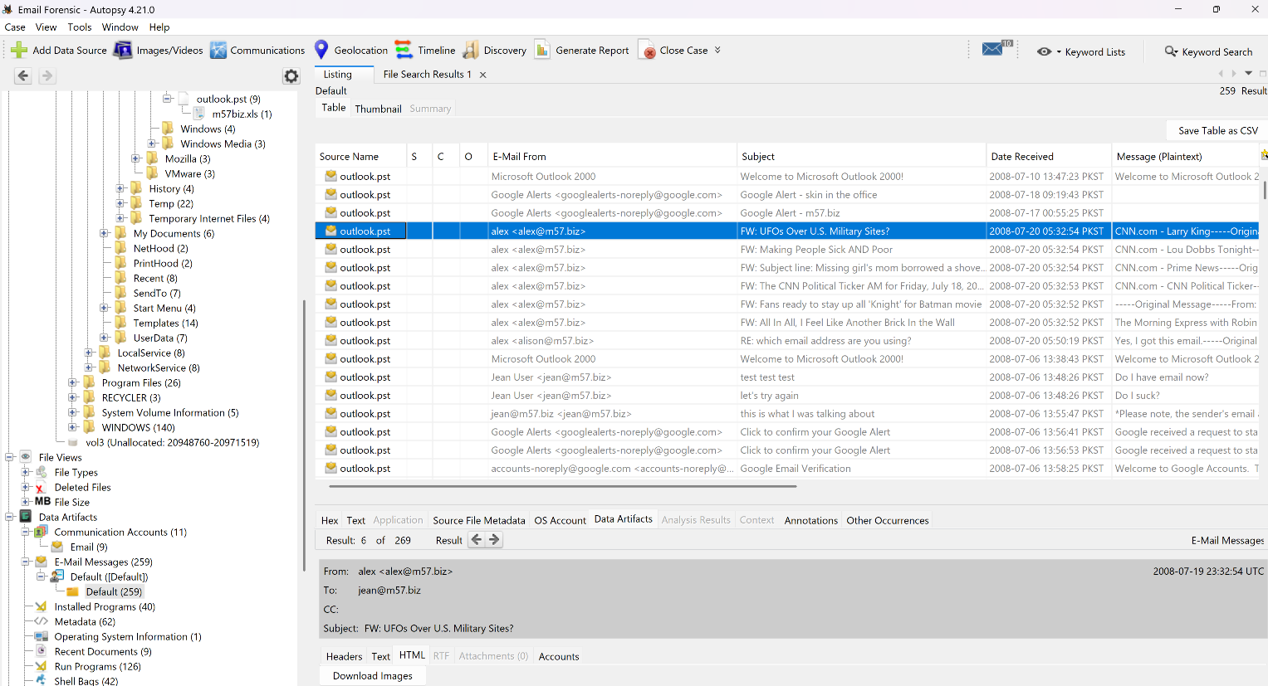
// 76-78 PART B — HOST-BASED ARTEFACT DEEP-DIVE

Target anchor timestamp for this section: 2008-07-20 01:28:03 GMT (m57plan.xls last-modified). LNK creation, Excel prefetch execution, and the RecentDocs registry update are each evaluated against this anchor; on a Windows XP-era image, artefact paths differ from Vista+ and are noted below.
$ Phase 7 — LNK File Analysis
Recent Items folder (XP path: Documents and Settings\jean\Recent) parsed for the m57plan.xls.lnk shortcut.
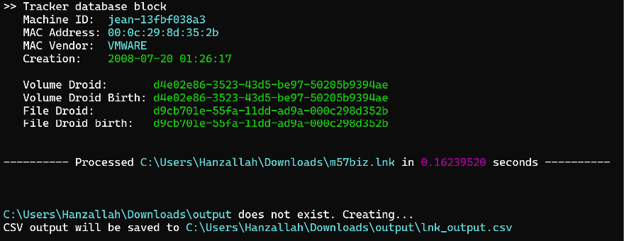
$ Phase 8 — Prefetch Analysis
Prefetch directory parsed for the EXCEL.EXE-<hash>.pf entry (XP prefetch path).
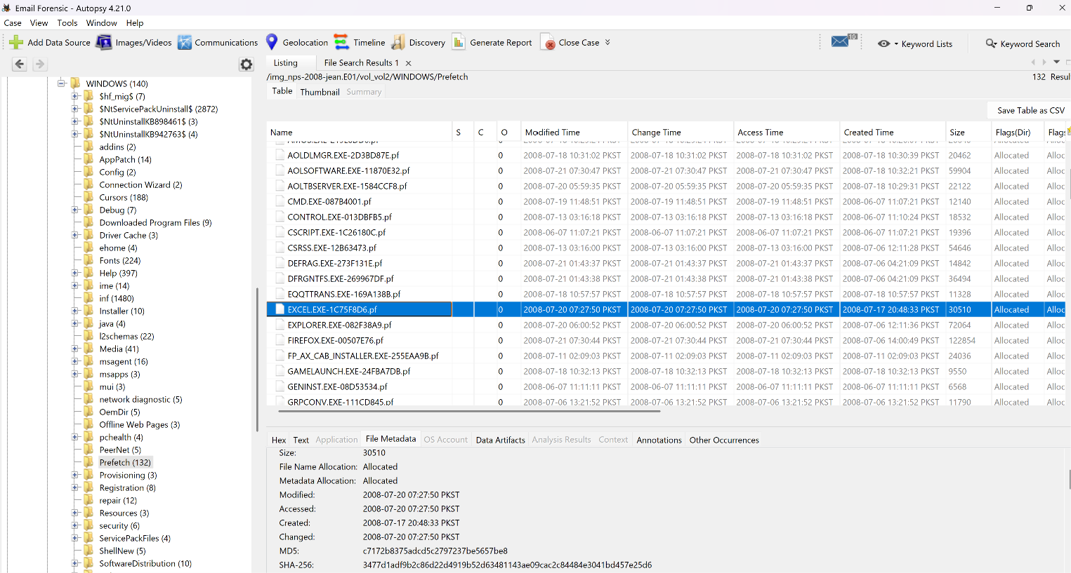

// 79-80 PART C — THE TIMELINE

The super timeline consolidates file system MAC times, registry writes, log entries, and parsed artefact timestamps into one sorted view, filtered aggressively down to the moments surrounding the target event.

$ Phase 9 — Super Timeline Generation
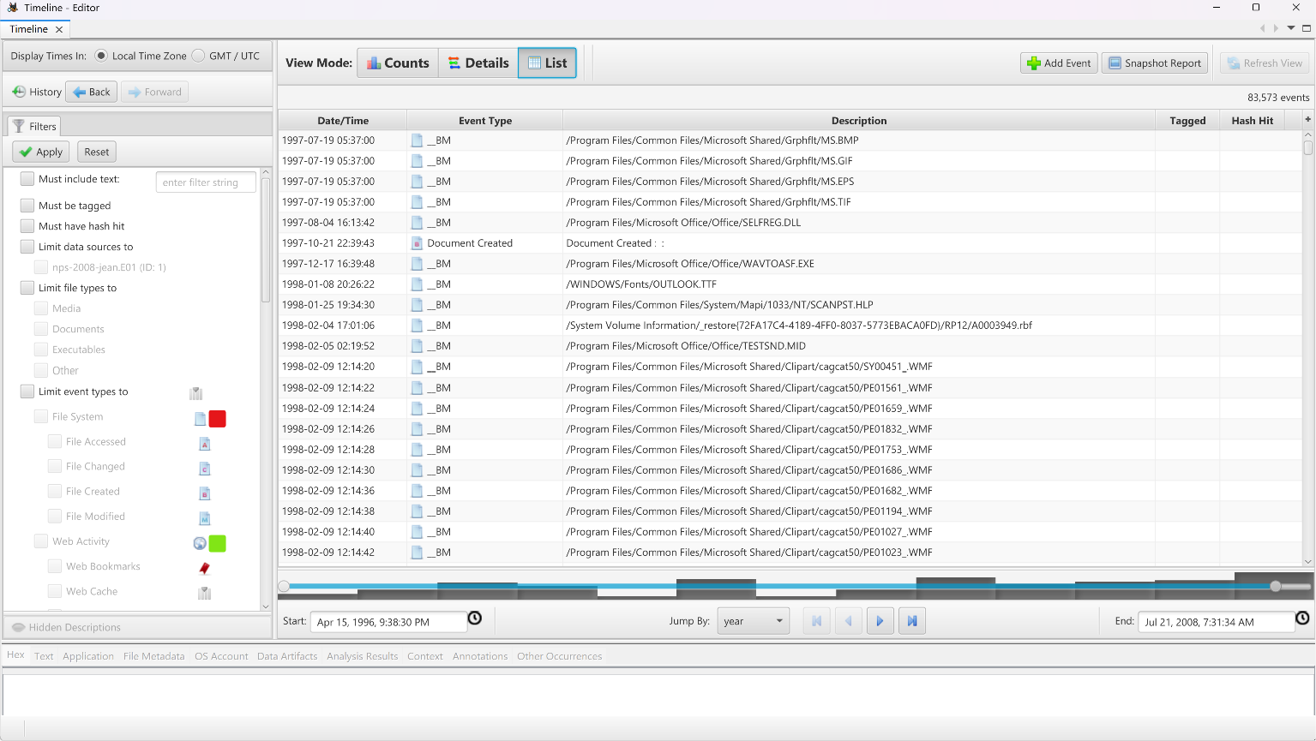
$ Phase 10 — Filtering: Date → Time Window → Keyword
Filters applied in sequence — date first, then the 01:25:00–01:30:00 GMT window, then the m57plan keyword — to avoid false matches from other dates.
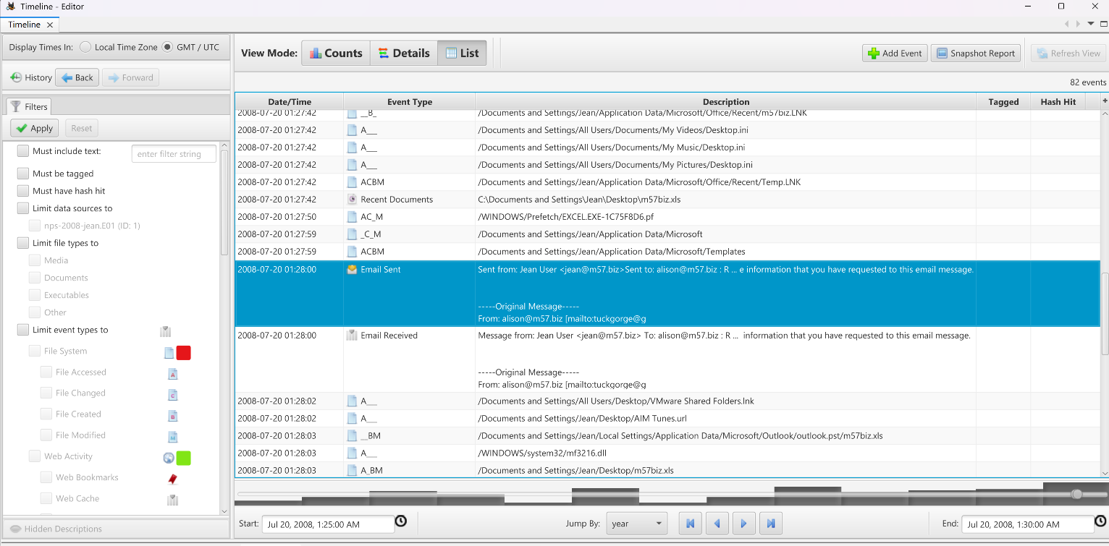
$ Investigation Conclusion
This phase investigates Jean's claim that she emailed the target file to the company President. Analysis of Jean's local Outlook store (outlook.pst) on nps-2008-jean.E01 identified the attachment as m57biz.xls (291,840 bytes), last modified 2008-07-20 01:28:03 GMT. Host-based artefacts a Recent-folder LNK shortcut pointing to Documents and Settings\Jean\Desktop\m57biz.xls on machine jean-13fbfc... (VMware) were cross-referenced against this anchor timestamp, alongside Excel prefetch execution, a RecentDocs registry write, and a filtered super timeline, to establish whether the file's actual delivery address matches its displayed recipient and whether local system activity corroborates Jean's account.
